**History-**

* The children will learn why nations were fighting and why child evacuees had to make long journeys from their families into unknown territories.
* Create timelines of major events including the introduction of rationing, the Battle of Britain, The Pearl Harbour Attack and Hitler’s death.

**English**-

* The children will draft evacuee letters that are factually accurate and use historical language.
* Write diaries inspired by the experiences of Anne Frank.
* Explore narrative dialogue, create propaganda posters and understand what makes a piece of writing superb!

**Computing-**

* The children will use search engines to research aspects of WWII. They will present these in a variety of ways, including a photostory.

**Learning Environment:** ***The children will be evacuated on Monday the 10th September*** **See attached letter.**

**Design and Technology**-

* Develop an understanding of ‘Make do and Mend’ researching and making popular wartime foods.
* Understand the structure of an Anderson Shelter.

**Jigsaw (PHSE) -**

* Our Topic is called ‘Being me in my World’.
* The children to empathise with others, comparing Jewish and German children during the war and investigating the meanings of the words *prejudice* and *discrimination*.
* Consider how it might it be possible to prevent another world war. What could we do?

**Physical Education**-

* The children will play wartime games such as hopscotch and tag.
* They will develop skills to play invasion games successfully.

**Geography** –

* The children will locate the destinations of evacuees in the UK, developing their understanding of cities, ports and the coastline.
* Understand why Plymouth was bombed.

**Music**-

The children will listen to and learn popular wartime songs. They will also explore a range of wartime sounds considering how music is used as a source of expression.

**A Child’s War**

**Y6**

[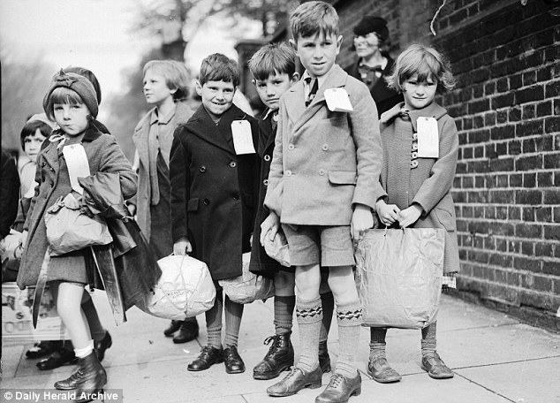](http://www.google.co.uk/url?sa=i&rct=j&q=&esrc=s&source=images&cd=&cad=rja&uact=8&ved=0ahUKEwjhvOW-4NXNAhWsLsAKHSx9BhUQjRwIBw&url=http://www.dailymail.co.uk/home/you/article-1362571/Julie-Summers-talks-evacuees-Second-World-War-life-changing-experiences.html&psig=AFQjCNEOvdtRpNAgbS3iroWceV6qsL3u0g&ust=1467582351745623)

**Y6**

**Foreign Languages**-

* Oak class will learn vocabulary for places in our school and school subjects.

***Innovate!***

The children will listen to Churchill’s end of war speech and plan their own VE Day party!

**Maths**-*Using and applying Maths skills:*

* Understand the rationing system and imperial weights and measures. Use co-ordinates to plot the journey of RAF flights.

In Y5 we will look at …