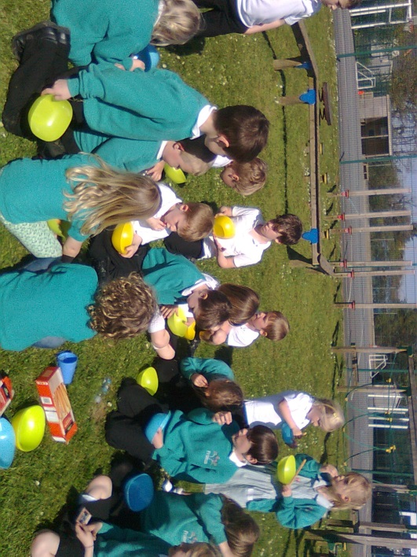

WELCOME GUIDE

Welcome to Kids Club Probus

available to children aged 3*-11 years attending Probus Primary School and
Little Acorns Probus Pre-School

The Club is open Monday~Friday during the following hours:

Breakfast Club : 7.45am ~ 8.45am
After School Club : 3.00pm ~ 6.00pm

Kids Club is run by Diane Gibbs and Julie Kennedy. All our staff are DBS checked and have up to date First Aid qualifications.

Club Contact Numbers:
01726 882647
07709 590963

Email: kidsclub@probusschool.org.uk

We do not open on Bank Holidays. However, we are open on Probus School INSET days.

Children attending clubs after school can be booked into Kids Club and will be taken across by a member of staff.

* Wraparound Care available to children at Little Acorns Probus Pre-School aged 3 years+ who are already in receipt of 3 & 4 year old funding

Breakfast

Children are offered breakfast, which includes cereal or toasted bagels/crumpets/tea cakes and fresh fruit all served with orange juice.

Snacks

Children are offered a snack after school which comprises fresh slices of fruit and vegetables alongside crackers/wraps and garlic bread/cheese on toast. There is a water cooler and children are encouraged to help themselves during the sessions. Children who are at the Club after 5pm are offered a light snack.

When the club opens on Inset days the children are offered two snacks a day, one at 10am and another one at 3pm. Children will need to bring in a packed lunch which they have at approx 12pm.

Bookings

Children can be booked into the Club via the phone numbers given or our email address. If you have to cancel your booking please inform a member of staff immediately (or let the office know asap). If for any reason you no longer need the facilities of Kids Club after school please inform a member of staff (so that we know your child has gone home safely). If less than 24 hours notice is given a cancellation fee will apply.

Please find a price list at the back of this guide for your information. A registration form is available on the website at http://www.probusschool.org.uk or for collection from school office or Kids Club, please complete before your child attends their first session.

Late Collection

If we have not received a phone call or email informing us that you will be late to pick up your child you will incur a charge, details of which can be found at the back of this welcome guide.

Please note we operate a ‘three strikes you’re out’ policy. If you are over 10 minutes late collecting your child three times per term, you will no longer be able to use Kids Club for the remainder of the term.

We would like all children in wraparound care to be collected by 6pm. If you are running late please contact us either through the main school number 01726 882647, school mobile number 07709 590963 or email us at the following address

kidsclub@probusschool.org.uk

The late collection charges will still apply.

Payment

Please pay for your child care via Parent Pay before or on the day of booking.

Activities

All children have the opportunity to take part in a variety of activities ranging from outdoor play (including time on the play equipment), football, treasure hunts/trails, various board games/puzzles, cooking, arts and crafts.

We also have fun on the 'Wii' games machine and football table. On Friday’s we enjoy a DVD film (complete with popcorn & hot chocolate!). Once every half term the children organise a "Pamper Afternoon"!

Kid’s Club Probus
Charges as at 1.10.2018

BREAKFAST & AFTER SCHOOL CLUB
Breakfast Club After School Club
(7.45-8.45am) (3.15 to 6pm)
1st Child | Subsequent Child | 1st Child | Subsequent Child
£4.50 | £4.00 | £15.00 | £8.00

After School Club break down:
Times | 1st Child | Subsequent Child
Up to 1 hour | £4.50 | £4.00
1 hour 30 mins | £6.50 | £4.50
Full Session | £15.00 | £8.00

INSET DAY
Half Day (or 5 hours) Full Day
(7.45-1pm) (7.45am to 6pm)
1st Child | Subsequent Child | 1st Child | Subsequent Child
£15.00 | £10.00 | £25.00 | £16.00

Cancellations
Normal charges will apply if less than 24 hours notice is received
(with the exception of infectious diseases)

Late Collections
Up to 10 minutes late: £10 per family charge
Up to 15 minutes late: £20 per family charge
Up to 20 minutes late: £30 per family charge
Then every 10 minutes late another £10 charge

All children must be booked into the club prior to them attending to ensure correct staffing ratios are in place.

