**Science**

This term we will be using scientific enquiries to answer specific questions raised from investigations.

We will be looking at mighty magnets and set up tests to discover how strong they really are. We will try to find out why magnets repel and attract by exploring the magnetic qualities of everyday materials We will be making systematic observations of friction at work, by comparing how different things move on different surfaces.

**English**- In addition to continuing to work on ensuring handwriting is accurately joined and correctly sized; we will be reading and writing the following text types

* + - * Character descriptions
      * Biography
      * Dialogue
      * Fairy Tales

**Foreign Language**

We will be exploring the French language using rhyme and simple French songs.

* Learning numbers 0-20
* Using numbers to tell our age
* Learning playground games

**Computing**

This term we will be creating web searches and using the internet to assist us when researching greatest heroes and villains

**Physical Education**

As well as participating in the daily mile we will be developing balance and agility using both fine and gross motor skills. working independently and in small groups.

**Art, Design & Technology**

We will be modelling and sculpting a bust of our hero or heroine using clay. In art we will bring the characters of 101 Dalmatians to life by creating flip books to suggest animated movement.

**PSHE**

We will be celebrating and accepting everybody is different, understanding how differences make us all special and unique. We will be learning how to identify right and wrong to help us solve problems.

**Cornwall Learning Skills for Life**

Considering British Values and how to apply them to our own lives.

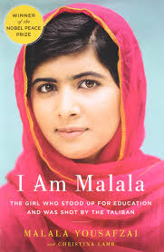

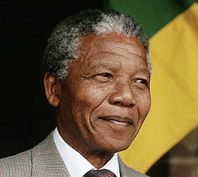

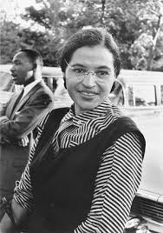



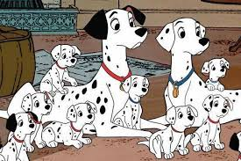

**Heroes and Villains**

**Autumn Term 2 2018**

**Learning Environment:**

In Year 3 this term we will be learning about Heroes and Villains. How does it feel to do good or bad things? Can we do a good deed that changes the world? We will be learning about the lives of Martin Luther King, Stephen Hawking, Joan of Arc, Rosa Parks, David Attenborough and Amy Johnson. There are many more heroes and heroines, but who do you admire the most? We will be singing about infamous villains Bugsy Malone and Cruella De Vil and creating rap songs about history’s greatest. Perhaps we could be heroes- just for a day?

**RE - Sikhism.**

We will be learning about the life of Guru Nanak the founder of the Sikh religion,

* + - * Exploring the Sikh beliefs, teachings and practices through celebrations and worship.
      * Describe and understand the links between different religious stories.

**Music**

We will be:

* Comparing and evaluating music
* Listening and appreciation
* Exploring notation and composition
* Practising rhythm.

**Maths**

This term we will be revising and revisiting

* Using money to add and subtract with the correct notation and place value.
* Fractions and fractions of numbers using doubling and halving
* Measurement, length and capacity
* Place value using number lines to compare, round numbers and find differences

