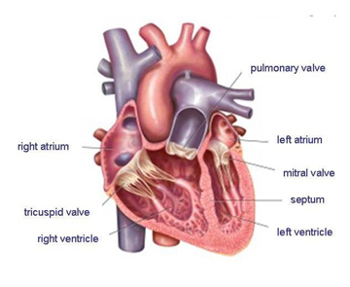

***To launch our topic, the children will look closely at a sheep’s heart and explore its structure- this will help to stimulate their curiosity and interest.***

**Art-** To model a heart out of clay, using photos from the dissection to help sculpt it.

Create abstract paintings using different shades of red and using a range of techniques- blow, smudge, mark and print.

**Physical Education**-

The children will continue to develop their skills when playing invasion games including netball, focusing on defensive skills. The children will also investigate how speed, strength and stamina can develop overtime when running and jumping.

**Music-** Feel your heartbeat and replicate the dub-dub sound musically. The children will also learn what the ‘pulse’ means when referring to a piece of music.

**Computing-** Visit the ‘Give Blood’ website and find key information and share our discoveries.

Create a flowchart diagram to illustrate the circulation process and create a short video clip about the importance of a healthy lifestyle.

**Maths**- The children will explore their heart rate in beats per minute, investigating if those in the class with slower resting heart rates are fitter by completing a 50m sprint.

They will construct pie charts representing different blood groups.

**English**- Our class text will be ‘Pig Heart Boy’, by Malorie Blackman. The children will write a descriptive story this half term possibly. They will also look at Anne Frank’s experience during WW2 and write a diary entry.

**Design and Technology**-

The children will investigate using a variety of funnels and tubing to make an effective stethoscope to find the furthest distance at which you can still hear a heartbeat through a tube. The children will be able to explain how the sound is transmitted.

**Foreign Languages**-

The children will learn vocabulary for animals and will learn to express their likes and dislikes.

**PSHE**- Share ‘The Heart and the Bottle’ by Oliver Jeffers, discussing what happens and how life might be different if you didn’t have a heart.

Our Jigsaw Unit of work is entitled: Celebrating Difference.

**RE-** The children will explore ‘Sundays’ in a variety of religions, including Christianity.

**Science**-

What makes the heartrate accelerate/decelerate?

The children will also explore the ABO blood group system and investigate how a liquid flows through straws of different diameters to investigate blood flow and the impact of blockages.

The children will also explore the topic of ‘sound’.

**Blood Heart**

**Oak Autumn 2**

In Y5 we will look at …