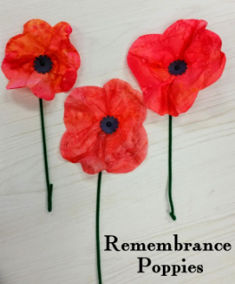 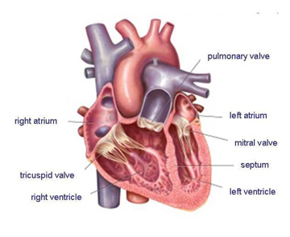

**Art-** To model a heart out of clay, using photos from the dissection to help sculpt it.

Create abstract paintings using different shades of red and using a range of techniques- blow, smudge, mark and print.

***The children will complete a short unit of work after half term called ‘Flanders’s Fields’. This***

***will focus on developing the children’s understanding of WW1 during this centenary***

***year.***

***Oak Class have been invited by the Parish Council to take part in a lantern parade on the evening of Sunday 11th November to mark this event- further details will follow in a letter.***

**Physical Education**-

The children will continue to develop their skills when playing invasion games including hockey, focusing on defensive skills. The children will also investigate how speed, strength and stamina can develop overtime when running and jumping.

**Music-** Feel your heartbeat and replicate the dub-dub sound musically. The children will also learn what the ‘pulse’ means when referring to a piece of music.

**Foreign Languages**-

The children will learn vocabulary for animals and food, being able to express their likes and dislikes.

**PSHE**- Share ‘The Heart and the Bottle’ by Oliver Jeffers, discussing what happens and how life might be different if you didn’t have a heart.

Our Jigsaw Unit of work is entitled: Celebrating Difference.

**RE-** The children will explore ‘Sundays’ in a variety of religions, including Christianity.

**English**- Our class text will be ‘Pig Heart Boy’, by Malorie Blackman, who recently wrote an episode of Dr Who. The children will edit their work from last half term, write a story and a report about how the heart works.

**Maths**- The children will explore their heart rate in beats per minute, investigating if those in the class with slower resting heart rates are fitter by completing a 50m sprint.

They will construct pie charts representing different blood groups.

**Design and Technology**-

The children will investigate using a variety of funnels and tubing to make an effective stethoscope to find the furthest distance at which you can still hear a heartbeat through a tube. The children will be able to explain how the sound is transmitted.

Look at a range of packaging for foods that claim health benefits, identifying words and phrases that encourage or persuade customers.

**Science**- ***To launch our topic, the children will dissect a sheep’s heart to stimulate their curiosity and help them understand the heart’s structure.***

What makes the heartrate accelerate/decelerate?

The children will also explore the ABO blood group system and investigate how a liquid flows through straws of different diameters to investigate blood flow and the impact of blockages.

**Blood Heart**

**Oak Autumn 2**

**Computing-** Visit the ‘Give Blood’ website and find key information and share our discoveries.

Create a flowchart diagram to illustrate the circulation process and create a short video clip about the importance of a healthy lifestyle.

In Y5 we will look at …