**Art / DT**

We will be using a range of materials creatively to design and make: animal masks; sculptures and models.

We will be developing our skills through: designing labels and making animal enclosures.

.

**Learning stimulus:** Our topic will be introduced with a VIRTUAL ‘Bring your pet to school’ day!

**Computing**

We will be using the web (laptops and ipads) to gather information about our topic.

We will be learning to retrieve images and investigate photography.

.

**Science**

We will be developing our scientific skills by:

Grouping animals.

Investigating animals’ needs.

Representing our findings in graphs.

**English**

**Opportunities for writing**:

* Recounts of experiences.
* Fables.
* Poems.
* Lists.
* Instructions.

**Reading:** reading, sharing and talking about animal, poems and information books and storybooks about animals.

.

**Willow**

**Summer 2 2021.**

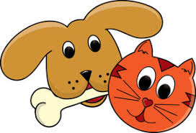

**‘Paws, Claws and Whiskers!’**

**RE**

Buddhism – Esala Perahera.

**From pets at home to ones at the zoo, let’s find out about these magnificent creatures.**

**Maths**

We will be continuing to consolidate our knowledge of our numbers and we will also be:

* Finding 2-digit numbers on a beaded line and 100 square; comparing and ordering 2-digit numbers.
* Recognising odd and even numbers; counting in 2s, 5s and 10s; multiplying by 2, 5 and 10 by counting groups of objects.
* Telling the time to the half hour and quarter hour on analogue clocks.
* Measuring lengths.
* Recognising and naming 2D shapes and continuing repeating patterns.
* Using number facts to add and subtract 1-digit numbers to and from 2-digit numbers.

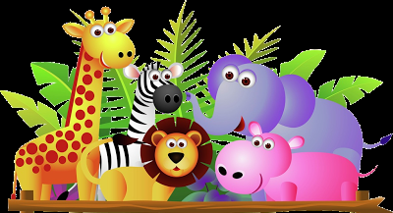

**PE**

We will be building our team skills through team sports.

**Geography**

We will be:

learning how to use maps.

Creating our own maps.

Describing physical features.

**PSHE**

Jigsaw topic: ‘**Changing Me**.’ We will be comparing how we are now to when we were a baby and explaining some of the changes that happen to us as we get older.

This plan shows the intended learning but may change due to pupil interests.